7

Polymer recycling   
by *open source additive manufacturing*

Fabio Cruz Sanchez1, Hakim Boudaoud1,   
Sandrine Hoppe2 and Mauricio Camargo1

1 ERPI, ENSGSI, Université de Lorraine, Nancy, France  
2 LRGP, Université de Lorraine, Nancy, France

Since the beginning of the 21st century, additive manufacturing has become increasingly accessible, at the same time with the emergence of the *Open Source Hardware* movement, namely technology design open to everyone. The conjunction of these two phenomena offered many opportunities for design and fabrication in the manufacturing industry, and also for the development of related activities, such as the recycling of thermoplastic materials.

This chapter proposes a general methodology for the recycling of thermoplastic polymers in a context of additive manufacturing. The methodology developed has been applied to the plastic material that is currently most commonly used in *open source* 3D printing, namely the polylactic acid (PLA). The material degradation level is assessed throughout the process by the characterization of the mechanical and physico-chemical properties, and we conclude that PLA can be recycled several times in order to be reused in 3D printing.

Finally, we study the implications of the diffusion of this type of recycling, and propose the study of short channel recycling of other thermoplastic polymers.

7.1. Introduction

At the beginning of this 21st century, given the current circumstances, it would be definitely delusional to expect a transformation of our entire society by technology alone. Technological revolutions are certainly here: the Internet boom, the interconnection and *peer to peer* exchanges, the emergence of new forms of energy, new production processes, new materials, etc. The expectation is to be a player and participate in the use of new technologies, but in a reasoned manner, taking into consideration the great challenges for the society, such as sharing and preserving resources and raw materials.

As part of our work, we present how a technological revolution such as the *open source*  additive manufacturing (AM) can be developed while considering the current social challenges, particularly tose related to the environment. This technology, also known as *open-source* (OS) 3D printing is one of the technologies acknowledged to have a strong potential impact on manufacturing systems, and also on a broader scale on our life style in the coming years. Its main distinctive feature compared to standard AM is the collaborative character of the *open source* leading to rapid and creative evolutions at lower cost. The first section of this chapter provides a broad definition of AM, followed by a state of the art of the studies conducted on recycling in the context of AM.

Finally, we discuss the potential of polymer recycling for *open source* AM and propose a methodology for the characterization of the physical degradation of the recycled materials all along the recycling and printing chain. The results obtained by applying the methodology proposed in the particular case of polylactic acid (PLA), which is widely used in 3D printing, will be presented as proofs of the concept. As a conclusion, the progress obtained in this work will be reviewed, and we will present prospective research paths leading to a better development of innovations of the current waste recycling systems thanks to *open source* additive manufacturing, which will at least partially contribute to solving the global problem of plastic material accumulation in nature.

7.2. Theoretical context

7.2.1. Commercial additive manufacturing (AM)

Additive manufacturing is the name given to “the set of processes for making physical objects, from 3D model data, layer upon layer and by adding material” (American Society for Testing and Materials 2012;Laverne et al. 2016). This approach differs from standard processes involving the removal or deformation of material, such as machining, foundry or forging. This is the basic principle of all additive manufacturing equipment, with several variations depending on the feedstock employed, the technique for making layers and the physical mean for the agglomeration of deposited layers.

Various terms have been used to refer to these manufacturing methods, such as rapid prototyping, layer manufacturing, digital manufacturing, rapid manufacturing, 3D printing. It should however be noted that the basic physical principle of AM has been used since late 19th century in photosculpture and topography (Bourell et al. 2009; Zhai et al. 2014). It consists of making a product by successive stacking of layers. Thanks to digital modeling, the sections of the 3D object to be made are defined by its successive cut-outs by parallel planes. The distance between sections corresponds to the layer thickness. To reconstruct the object, the sections are sequentially stacked one on top of the other.

A common approach to the classification of various types of AM technologies relies on the initial state of the feedstock used. This chapter does not cover the processes involving metallic materials, the focus being on processes employing the polymers listed in the classification proposed in figure 7.1.

Figure 7.1. Classification of AM technologies.   
Adapted from (*Cruz Sanchez et al. 2020*)

This chapter focuses on the *Fused Filament Fabrication* (FFF) process, more commonly known as *Fused Deposition Modeling* (FDM), trademark registered by Stratasys. It is one of the most widespread AM technologies in the world.

The principle of this technology is the deposition of a melted material filament, usually a plastic filament, on a substrate, using a mobile head. The material is heated at a temperature slightly above its melting point in the head, then extruded by a nozzle on a substrate and cooled until it solidifies and forms a layer. Thermoplastic polymers are materials commonly used by this technology. The patent for the molten filament deposition was granted in June 1992 (US Patent 5121329) (Crump 1988, 1991).

7.2.2. Definition of open source AM

Since the beginning of 2000, a new form of AM emerged thanks to the democratization of this technology for communities other than companies and research communities. The notion of *open source* AM (also known as *open source* (OS) 3D printing) is becoming a viable manufacturing option due to a combination of some elements, such as: 1) expiry of the first patents protecting the commercial technology of AM (particularly the *Fused Deposition Modeling* (FDM)), 2) evolution of information and communication technologies, and 3) common-based peer production and development modes (Grodzinsky et al. 2006)).

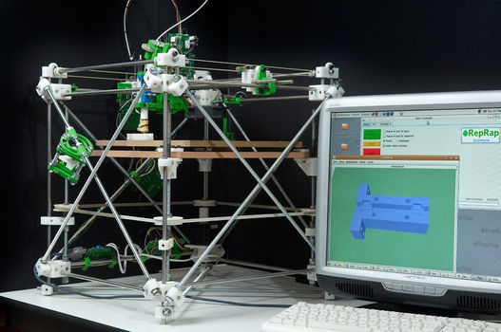

Figure 7.2. First RepRap machine, known as Darwin, may 2007

One of the first initiatives for AM democratization was implemented by Adrian Bowyer and his team through the project known as RepRap (or *Replicating Rapid-prototyper*) (Sells *et al*. 2009; Holland et al. 2010; Jones et al. 2011). RepRap is a British project of the University of Bath, aimed at creating a three-dimensional printer that is mostly self-replicating and free (without patent, and whose technical information is freely available to anyone) under GNU general public license.

This project relies on the principle of *Fused Filament Fabrication*[1]. The design of this machine relies on a relation of interdependence between machine and user. The machine fabricates the parts and the user assembles these parts. This is why the RepRap machine can be defined as “a kinematic assisted self-replicating and self-manufacturing machine” (Jones et al. 2011).

Based on this definition, three specific features can be identified:

1) The number of machines and the wealth they create might increase exponentially;

2) The machine becomes a subject of evolution by artificial selection;

3) The machine creates wealth with a minimal dependence on industrial production.

Figure 7.3 confirms the exponential growth of this type of machines. According to a recent work by Ford (2014) these types of *open source* technologies are currently the most commonly used additive manufacturing machines.

Thanks to the democratization of these projects, manufacturing high-value complex products has become accessible to everyone (Kostakis and Papachristou 2014; Pearce 2014).

Table 7.1 compares some characteristics of *open source* and commercial additive manufacturing. The main elements that explain the exponential growth and the interest of this type of machines for the general public are: lower cost compared to the commercial machines, availability of technical information, and the support of an entire community connected to the Internet around this technology. These key elements were the driving force of its democratization process. Moreover, this technology may have a positive impact on the communities, such as university laboratories, schools and may open new paths to science teaching, which may have an important impact due to its accessibility, in developing countries (Irwin et al. 2014).

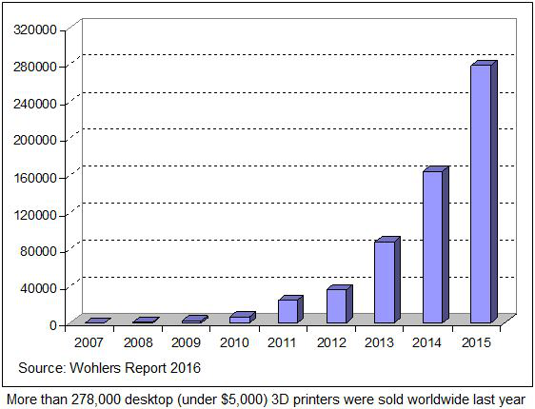

Figure 7.3. Number of open source machines   
(source: Wohlers Report 2016)

|  | ***open source* AM** | **Commercial AM** |
| --- | --- | --- |
| **Principle** | CAD + GCode + Printing | CAD + GCode + Printing |
| **Cost** | 200 $-5 000 $ | 5 000 $ jusqu’à 800 K$ |
| **Methodology** | *Open Design* | *Closed Design* (*Patented*) |
| **Developed by** | Global community | Several companies |
| **Printer** | Customized | Standardized |
| **Example** | RepRap Project | Stratasys |

Table 7.1. Comparison of open source and commercial machines

7.2.3. Polymer recycling

The development of polymer materials opened the way for manufacturing a broad range of inexpensive, low-weight and high-performance products and it became an essential element of the technological and social development (Andrady and Neal 2009). However, one of the main problems is the environmental impact of plastic residues due to their longevity, which may reach several decades (Hopewell *et al.* 2009).

In the industrial ecology of polymers, various strategies for plastic waste management have been studied, from reuse and recycling (mechanical, chemical) to thermolysis/recovery processes (Clift 1997; Al-Salem   
*et al.* 2009; Hopewell et al. 2009).

In the context of recycling of thermoplastics, one of the strategies developed for waste treatment is mechanical recycling. Mechanical recycling is defined as a process in which plastic waste is directly used in the manufacturing of new products. In this case, except for several modifications of its physical properties, there is no significant destruction of the polymer chemical structure (Fisher 2004;Perugini et al. 2005;Al-Salem et al. 2009; Hopewell et al. 2009;Robin 2012).

In this sense, the coupling of characterization tests with multiple processes of extrusion or injection molding is a proven approach for the assessment of the recyclability of polymer materials in order to simulate the extended life cycle of recycled products. Figure 7.4 presents a general diagram of this approach.

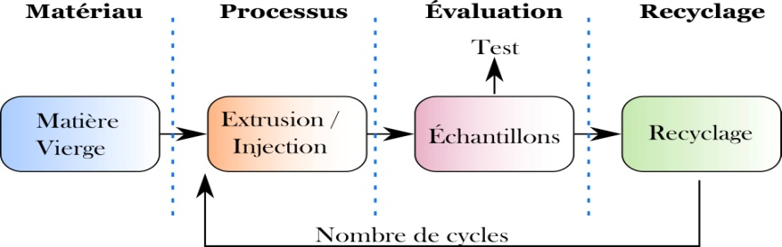

Figure 7.4. Stages of mechanical recycling

In this model, a starting phase is to consider the study of an “original resource”. A further consideration is the closed loop assessment of the material, therefore with no additional material input once the recycling process started. The degradation of the material is directly related to the process employed and to the number of cycles studied in recycling.

The “assessment” stage should be defined in order to have a quantification of the properties of the recycled material. In the case of the recycled plastic material, the works of Karlsson (2004) and Vilaplana and Karlsson (2008) have identified three major axes for quality assessment, which can be summarized as follows:

* degree of mixing (DM):this axis measures the presence of types of polymers and impurities in the material;
* low molecular weight compounds (LMWC):this axis refers to the presence of contaminants, additives and other elements in the matrix. It is important for meeting legal requirements;
* degree of degradation (DD):this axis determines the evolution of the degradation of the polymer at macro/microscopic scale due to the manufacturing process and to the life duration of the material.

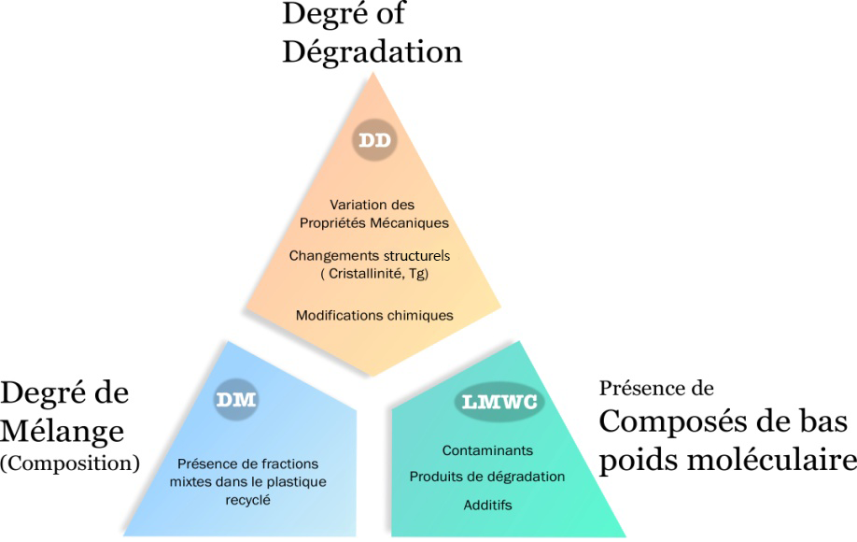

Degré de dégradation

Présence de Composés de bas poids moléculaire

Degré de Mélange

(Composition)

Figure 7.5. Assessment framework for recycled plastic material

The works of Badia and Ribes-Greus (2016) present a complete multilevel characterization representing the various axes of analysis (DM, LMWC, DD), and also the analytical techniques commonly used to test the state of performance and/or of degradation of the resulting material. Finally, depending on the properties that will be analyzed during the mechanical recycling process, adequate experimental protocols can be implemented. Finally, one recycling stage is characterized in order to be able to reuse the material.

7.3. Recycling in additive manufacturing

Now that the possibilities and characteristics of AM have been presented, it is important to recall that the main objective of this chapter is to gain a better understanding of the polymer recycling process in order to establish a sustainable waste management option for this *open source* AM technology. For this purpose, it is essential to be aware of the advances in the research and development of the use of the material recycled by AM technologies. Research focuses on the recycling of polymers used for *open source* machines. Similarly, the purpose is to identify the developments at the experimental/machine and methodological research level in order to understand the feasibility of this process.

Cruz Sanchez et al. (2020) conducted a systematic literature review over 120 articles from 2009 to 2020 by identifying the most important elements, concerning the recycling of thermoplastic materials, supported by AM (type of material, quality assessment protocol, properties in printing). These elements can be used to understand the viability of their use for recycled materials.

A first result of the literature review is that the recyclability studies in the context of AM processes such as stereolithography (SLA) are still a research field to be explored. On the other hand, several propositions have been identified in the *Selective Laser Sintering* (SLS) and FFF processes.

In the context of commercial AM technologies, recycling methodologies have been identified in order to assess the feedstock that was not sintered during the SLS printing process*.* Nandwana *et al.* (2016) explain a methodology used for the evaluation of the recycling of metallic powders in the EBM process. In the case of the polymer, Dotchev and Yusoff (2009) presented a methodological approach to evaluate the good practices established for the recycling of powders in the sintering of powder (SLS), by using polyamide (nylon).

In the context of *open source* AM*,* one of the important concepts to be underlined is that of distributed recycling . This concept applies to using plastic waste to transform it into feedstock for the 3D printer thanks to the *open source* development of extruders.

The coupling of 3D printers with extruders has been explored as a new prospective approach to optimize the feedstock for these machines. Some projects such as *Precious plastic*[2] (Hakkens 2016), *Plastic Bank*[3] are nowadays based on this concept.

Figure 7.6 presents the technical system that must be rendered viable for the development of a short channel, in order to use 3D printing technology as a driving force for small-scale waste recovery.

Figure 7.6. Conceptual framework of distributed recycling technical process

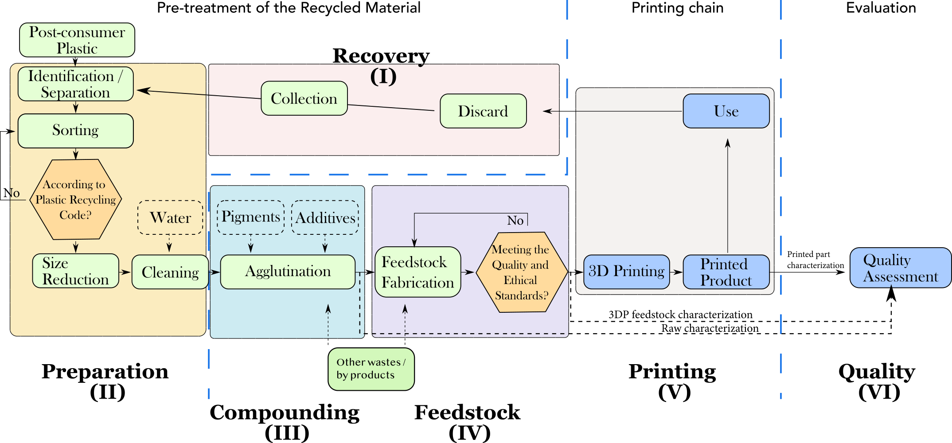

The main interest of this approach is to reduce costs and greenhouse gas emissions related to waste collection and transportation, and also to the environmental impact of manufacturing customized plastic parts. This approach of distributed polymer recycling might be an additional alternative to standard centralized recycling of polymers (Baechler *et al.* 2013; Kreiger *et al.* 2013, 2014; Kreiger and Pearce 2013; Feeley et al. 2014). Considering the significant increasing adoption of *open source* AM, the distributed recycling of polymers might be a very relevant approach, as the current recycling rates are very low.

From an economic point of view, the costs of commercial filaments ranges between 18.86 $ and 175.20 $ per kg, which is 20 to 200 times higher than the cost of raw plastic. Wittbrodt et al. (2013) and Kreiger *et al.* (2014) proved the economic feasibility of a distributed model with the local recycling of plastic materials (recycled filament) for OS 3D printers in which 1 kg of recycled filament has been manufactured from about 20 bottles of milk for less than 10 $ cents by using the *open source* extruder prototype known as “Recyclebot”. Concerning the energy aspect, Kreiger and Pearce (2013) and Baechler et al. (2013) have worked on the concept for the recycling of high value polymer waste, where the intrinsic energy savings range between 69% and 82% for the distributed recycling compared to the centralized approach of standard recycling. Consequently, there is an interest in recycling polymer materials in a context of *open source* 3D printing.

However, to understand the polymer recycling process in order to establish a sustainable waste management option for this *open source* AM technology*,* two fundamental elements must be taken into account: 1) given the *open source* nature of the machines, a characterization is needed in order to understand the performance of these machines with respect to all the manufacturing processes. Moreover, the relation between the manufacturing parameters/process/obtained properties must be clarified.

Once the performance of OS machines is characterized, the focus is first on the process of degradation of the physico-chemical properties of the polymer at each recycling cycle. The next step is to determine how to treat it and thus validate the relevance and the number of times that a material can be recycled.

7.4. Proposal of methodology to evaluate the recyclability potential of polymers for additive manufacturing

Based on the characteristics of the mechanical recycling process, our proposal is to adapt a systematic methodology to evaluate the degradation of thermoplastic polymers in the chain of 3D printing processes. This methodology can be used to compare the degradation of the material by using a standard manufacturing process (for example, injection) with respect to printing. Moreover, a second aim is to quantify the impact of the printing process itself on the degradation of the material. Figure 7.7 illustrates the proposed methodology.

1. Définition du matériau

3. Fabrication des échantillons

4. Évaluation

2. Définition des Procédés

5. Recyclage

Figure 7.7. Methodology for assessing the feasibility of recycling for   
open source AM

Each stage will be explained in the following sections.

7.4.1. Stage 1: Definition of the material

The main purpose of this stage, entitled “definition of the material” (figure 7.7) is the characterization of the feedstock to be studied. The characteristics given by the supplier of the polymer must be taken into account for the initial setting of the operating conditions.

Likewise, the total amount of material necessary for the global study must be assessed. However, in order to have an actual assessment of the quantity of material, the elements that will be defined in the next stages should be taken into account. These elements are:

* identification of the properties of the material to be studied during the recycling process;
* definition of the chains of recycling processes required for the characterization of the degraded material;
* definition of the number of cycles to be tested;

estimation of the potential material loss during the recycling cycles, in order to predict from the beginning of the experimentation the adequate quantities of material.

7.4.2. Stage 2: Definition of processes

This stage is divided into two parts (figure 7.7).

7.4.2.1. Identification of the recycling processes

This refers to the identification of recycling technologies that will be used for the characterization of the properties of the recycled polymer. In order to highlight the effects of various processes on the material, at least four recycling chains are required to compare the degradation of the material:

* reference process: it is used as a reference for the degradation of the recycled material;
* *3D printing*: it is used to assess the degradation of the material following the 3D printing process with samples made with a 3D printer for a given set of parameters;
* *feedstock*: it is used to assess the impact of the degradation due to the manufacturing of raw material for the considered 3D printing machines (filaments, granules, powder, etc.);

3DP (reference): it is used to assess the degradation of the material due to the 3D printing process with standard equipment.

Moreover, several mechanical, thermal, rheological and morphological features can illustrate the degradation of the polymer (Vilaplana *et al.* 2007; Vilaplana and Karlsson 2008). During this stage, the experimenter must determine his choice, by selecting the properties to be studied by the recycling process.

7.4.2.2. Feedstock preparation for 3D printing

This stage aims to identify the processes required for the manufacturing of feedstock for the printer. Therefore these processes must be characterized and operating conditions must be set in order to define the various properties. Moreover, a definition of the quality of the material obtained is essential for ensuring quality during the printing process.

7.4.3. Stage 3: Manufacturing of samples

Two types of processes are proposed in order to compare the degradation of the material: standard processes and 3D printing:

* standard: this process will serve as a reference for comparing the results obtained from degradation with the 3D printing process. A necessary step is to characterize the equipment and define the operating conditions for manufacturing the samples that will be the reference of degradation. It is the reason why it is imperative to identify the international standards with respect to the properties selected in the previous stage;

3D printing: firstly, the objective is to characterize the *open source* printer used in the experimentation; secondly, to define the manufacturing parameters for the samples. A review of the literature on the selected property in the context of commercial additive manufacturing may provide an initial overview of the important parameters to be considered.

7.4.4. Stage 4: Assessment

The main objective of this stage is the definition of the parameters describing the targeted properties and the definition of the equipment selected for assessment. Tests have been conducted in order to gather data according to international standards, and by considering also the set of samples according to the proposed recycling stages.

7.4.5. Stage 5: Recycling

Finally, the objective of this stage is to condition the recycled material for retreatment. The recycling process is individually conducted for each recycling chain. The recycling equipment used is characterized and the specific features of the recycled material obtained are described.

7.5. Case study: recycling of polylactic acid (PLA) for FFF 3D printing

7.5.1. Stage 1: definition of the material: polylactic acid (PLA)

The methodology presented in figure 7.7 is applied to a particular case. The selected material is polylactic acid (PLA) 4043D (NatureWorks). This material is used for the manufacturing of feedstock for 3D printers, according to the manufacturer specifications.

Polylactic acid (PLA) is one of the most important biosourced, biodegradable and biocompatible polymers (Drumright *et al.* 2000; Mohanty *et al.* 2000; Henton *et al.* 2005; Luckachan and Pillai 2011; Soroudi and Jakubowicz 2013). PLA is an aliphatic thermoplastic polyester obtained from renewable resources (for example, potato, corn starch, sugar cane and corn sugar) using a ring-opening polymerization of lactide (Agrawal and Bhalla 2003; Hamad *et al.* 2013; Castro-Aguirre et al. 2016). PLA offers many advantages for a wide range of applications of products such as bottles, trays, containers, among others.

7.5.2. Stage 2: Definition of processes

Recycling processes: an adaptation of the mechanical recycling process was made in order to define the recycling chains. Figure 7.8 presents the four recycling chains whose final objective is to qualify the degradation of the mechanical properties following various processes.

The “material” stage was defined in the previous section, assuming that virgin materials are used in the recycling process. As for the “process” stage, the material is expected to be degraded by these three processes (injection, extrusion and 3D printing). The four recycling chains make it possible to understand and compare the impact of each process on the degradation of the material.

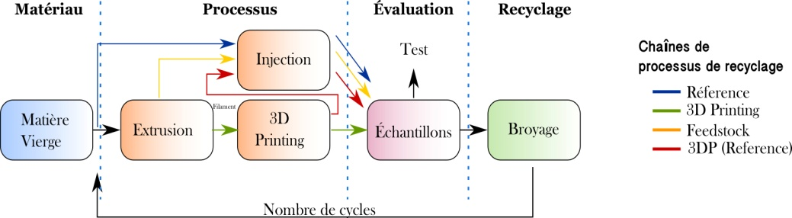

Figure 7.8. Recycling chains for assessing the degradation of the material

Preparation of the feedstock for 3D printing: the polymer can be extruded into monofilament by hot extrusion, which is one of the most important techniques for the ongoing treatment of PLA (Gupta *et al.* 2007; Lim *et al.* 2008). In all cases, there are some elements to be considered concerning the demands related to the base material for 3D printers.

In terms of mechanical properties, the filament should have some characteristics, such as:

* High bending modulus and elasticity modulus, allowing ongoing winding and unwinding;
* High compression strength to prevent it from breaking after passage through 3D printer rollers;

Uniform average diameter and rheological and extrudability properties so that the filament can be printed without using a compressive force exceeding the limits of the extrusion material.

The parameter selected for assessing the feedstock quality was the uniformity of the diameter ($ϕ$). This value is an input data for our printing process.

For the needs of this experiment, this process is considered as the sum of three systems, namely: 1) the feeding system, 2) the extrusion process and 3) the conveyor system, as shown in figure 7.9.

The feeding system consists of a K-TRON twin screw volumetric feeder (K-MV-KT20). The feed rate is controlled by the motor speed and the gear reducer and a horizontal stirrer slowly moves the bulk material to the large groove, then to the screws. The conditions of the parameters of the feeding system are 100 RPM for the motor using granule size. The feeding speed was set at .

Figure 7.9: Extrusion process for making filaments

The extrusion process is used for making the filament used in the 3D printing process. It employed a conical counter-rotating twin screw extruder HAAKETM Rheomex CTW 100 OS at the laboratory scale.

The operating speed of this machine ranges between 0 and 250 rpm. The speed of the screw was set at 60 rpm. The selected temperature profile was 160, 170 and 180 °C.

Moreover, a conveyor system was adapted to properly control the filament take-up after extrusion. Finally, a belt conveyor system is used to cool (by natural convection nature) and collect the extruded filament.

7.5.3. Stage 3: Manufacturing of samples

– Standard: micro-compounding and injection: the micro-compounding process was selected as our standard manufacturing process (figure 7.10). It provides a basis for the comparison between various recycled materials. This type of machines can work with a small quantity of material (3 to 15 g) with a treatment history similar to that of classical twin screw extruders.

The polymer material was treated using a discontinuous micro-compactor with corotating twin screws with DSM Xplore gear of 5 cm3. The diameter of the screw of this device decreases from 1 cm to 0.43 cm over a length of 10.75 cm.

The parameters adopted are constant temperature of 180°C, between the feeder groove and the threader, and a screw speed of 100 rpm in counter-rotating mode. The extruded material was taken after a mixing time of 3 minutes. The temperatures of the melted material and of the mold were 190°C and 45°C, respectively. The melted material was directly injected using a transfer cylinder of the injection molding machine DSM Xplore 10 ml in order to obtain mechanical samples. The injection and hold pressure were set at 9 bars for 30 s. The specimens were carefully withdrawn from the mold after 5 min of cooling.

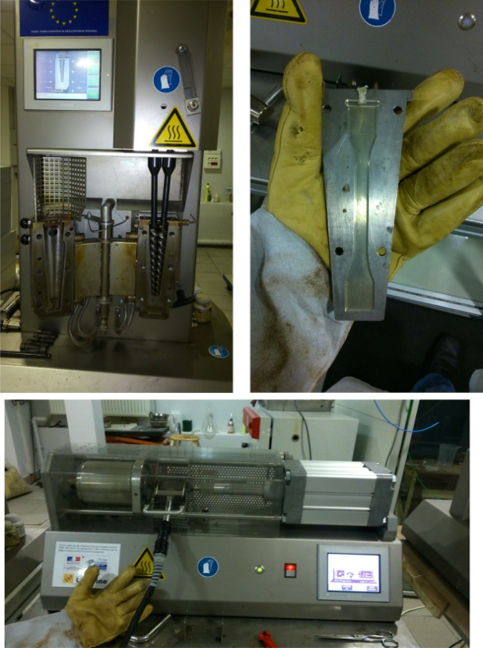

Figure 7.10. Micro-compounding process

*3D printing*: *Fused Filament Fabrication* (FFF): as previously mentioned, one of the main characteristics of open-source 3D printing is that it was an object of social experimentation, in which many enthusiasts and communities developed a significant number of architectures of 3D printing machines (Kostakis and Papachristou 2014). Consequently, given the highly customized nature, there are various configurations of the architecture of the machine, which leads to an inherent variability between various 3D printers. The *open source* 3D printer should be characterized in order to ensure the reproducibility of the printed parts (Cruz Sanchez *et al.* 2014).

Figure 7.11 presents the two types of 3D printers selected for the manufacturing of samples in this study.

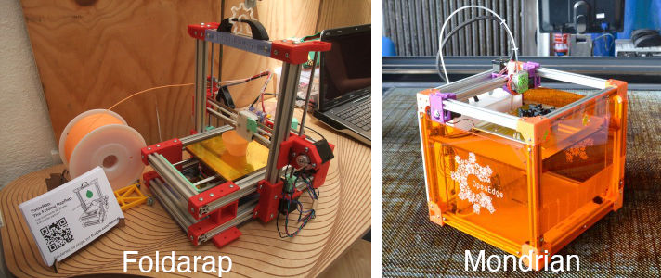

Figure 7.11. FoldaRap and Mondrian open source printers

These are 3D printers representative for the set of OS machines developed by the RepRap community, known as Mondrian and FoldaRap(figure 7.11)*.* These are versions of the RepRap machine with a working capacity of 140 x 140 x 155 (mm3) and 200 x 200 x 200 (mm3) for FoldaRap and Mondrian, respectively.

The extrusion system can be moved in the XY horizontal plane and the heated printing bed can be moved in the vertical direction – Z. The resolution obtained is $XY=0.0125 mm$ and $Z=0.00025 mm$ with rods.

The heated printing bed is made from aluminum connected to a Peltier cell and it uses an upper kapton layer to improve the adherence of the part to the printing bed.

Figure 7.12 shows the process parameters to be taken into account for manufacturing printed samples.

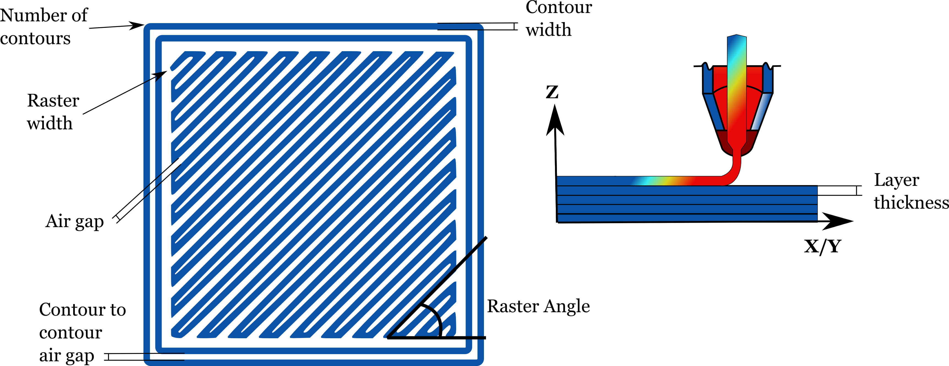

Figure 7.12. Key parameters in the printing process

They can be defined as follows:

* build direction of the part: it refers to the orientation of the part in a building platform with respect to the X, Y and Z axes. The X and Y axes are considered parallel to the building platform. The Z axis is considered the printing axis;
* thickness of the layer: it is the height of the layer deposited by the nozzle;
* filling angle: it is the orientation of the deposited filament lines with respect to the x axis of the machining bench. Typical configurations are 90/90 and 45/45;
* airgap: it is the space between two adjacent filaments of material on the same layer. A zero value means that rasters are touching. A positive value means there is a space. A negative value means that rasters are overlapping;
* number of contours: it defines the number of solid perimeters of the object;

velocity of the printing head: it is the velocity of the printing nozzle when it makes the object (velocity of perimeters, small perimeters, external perimeters, filling – solid, upper, lower layers).

In terms of dimensional accuracy, various works aimed to characterize the dimensional performance of *open source* 3D printers. According to the international standard of tolerance, the grade of this type of machines can range between IT14 and IT16 (Cruz Sanchez et al. 2014). Moreover, according to the works of Cruz Sanchez et al.(2014), parameters such as layer thickness, raster width and velocity of the nozzle may impact the machine accuracy.

On the other hand, if we consider the mechanical properties of the material in the additive manufacturing technology based on extruded systems, an important conclusion of the literature is that there is an anisotropic behavior. This means that the properties of the material depend on direction. The mechanical integrity of the printed part is directly linked to factors such as the energy of adhesion/cohesion between layers and deposited layers, the increase of the contact zone formed between adjacent layers, the molecular diffusion and the randomization of polymer chains through the interface, and a minimum residence time at high temperature to ensure adequate levels of diffusive bond (Agarwala *et al.* 1996; Atif Yardimci and Güçeri 1996; Yardimci *et al.* 1997; Sun et al. 2008). Moreover, the thermal history of interfaces plays an important role in determining the bonding quality. The unequal heating and cooling cycles due to the inherent nature of the printing process lead to a build-up of constraints in the built part, which is mainly responsible for the bonding weakness and affects the strength. For this reason, mechanical properties depend on the tool path and on the orientation of the part (Es-Said et al. 2000; Ahn et al. 2002; Bellini and Güçeri2003. Consequently, the mechanical properties depend on manufacturing parameters, as they impact the mesostructure and the bonding force between fibers (Lee et al. 2005,2007;Sood et al. 2010,2012;Croccolo et al. 2013;Tymrak et al. 2014).

7.5.4. Stage 4: Assessment: mechanical properties

ISO 597 standard is used to determine the tensile properties of the recycled material. The test specimen used is ISO 527 1B. Figure 7.13 shows the measures of this test specimen in mm. This standard applies to plastics as molded, extruded and cast materials, filled and not filled, plastic films and sheets, and also to long-fiber reinforced composites.

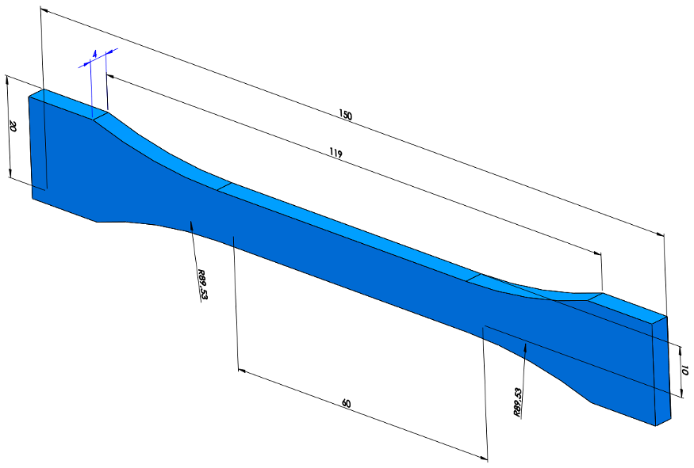

Figure 7.13. Test specimen for mechanical characterization according to ISO 527 1B

7.5.5. Stage5: recycling

The size of the samples of each recycling cycle must be reduced in order to retreat the material. An SM 300 Retsch® cutting mill with a speed range from 700 to 3 000 rpm has been used, as illustrated in figure 7.14.

The selected speed was 700 rpm. The final size obtained ranges between 0.2 and 2 mm.

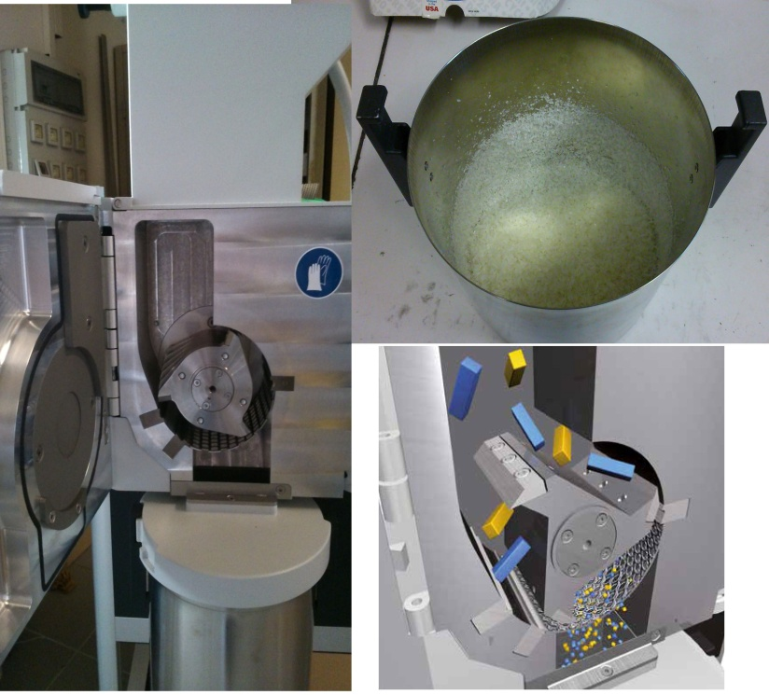

Figure 7.14. Recycling chains for assessing the degradation of the material

7.6. Results

Based on these four recycling chains, it is possible to compare the degradation of the material by using a standard process, such as injection and 3D printing process.

Figure 7.15 presents several examples of samples produced with our experimental approach.

Figure 7.15. Test specimens of standard and 3D printing recycling chain

We selected 8 samples for each recycling chain and each cycle in order to ensure the reproducibility of results. In the case of the *3D printing* chain, 16 samples have been selected; 8 for 0/90 filling, and 8 for 45/45. A first observation of the comparison is that in all the cases, the injected samples have better properties than the printed ones, as presented in figure 7.16. The difference between these two manufacturing processes is of about 10 MPa in the first cycle, which is confirmed by the literature (Tymrak *et al.* 2014; Wittbrodt and Pearce 2015). However, this difference increases up to about 20 MPa in the fifth cycle.

According to the results represented in figure 7.16b, the elastic modulus can be considered as independent from the recycling and manufacturing process. It could be considered as constant for the injected samples (reference chain) in a range of variation between 3 300 and 3 500 MPa. For the case of printed samples (45/45 and 0/90), a small increase in the elastic modulus is observed from the first to the last cycle with average values from 3277.7 to 3 432.6 MPa, respectively.

a)

b)

Figure 7.16. Mechanical properties of the “reference” and 3D printing chains

A possible explanation for this increase in the elastic modulus for the printed samples is that it is associated with the change in viscosity of the material, as a consequence of the recycling process. The characteristics of the mesostructure and of the fiber-fiber bond of the printing samples will also change as the number of recycling cycles increases. According to the literature, some internal defects that affect the structural quality of the printed parts are: voids, pores and sub-perimeter voids due to the rounded and elongated shape of the deposited material (Agarwala *et al.* 1996; Turner *et al.* 2014). In the printing process, the printed material propagates in an elongated shape whose spread rate and final shape depend on the viscosity of the melted material and on the relative surface energies of the deposited raster and on the surface on which it is printed (Turner et al. 2014). Finally, the overall mechanical properties of the part will depend on the contact zone between the deposited rasters (and layers), on the size of the voids and on the properties of the material.

Consequently, a hypothesis for explaining the similar behavior of the reference and 3D printing process chains in terms of elastic modulus at the end of the fifth cycle is that internal defects are significantly reduced, as result of the decrease in material viscosity, which facilitates the homogenization of the deposited layers. It can then be assumed that the internal mesostructure of the printed samples might be similar to that of the injection. Nevertheless, this reduction of viscosity is a consequence of the degradation of the material, driving a change in the tensile properties.

On the other hand, figures 7.17a and 7.17b show the results of the mechanical properties of the *Feedstock* and *3D printing* (reference) recycling chains. The only difference between these two chains is a 3D printing process in the degradation of material. Concerning the elastic modulus, it can be noted that it remains virtually constant during the cycles. Moreover, 3D printing effect on the material can be noted. It is negligible when the material is raw, on the other hand this influence is stronger as the material is increasingly degraded. It is important to analyze these results from a chemical point of view in order to characterize the degradation at microscopic level.

a)

b)

Figure 7.17. Average values of tensile strength and elastic modulus for Feedstock and 3D printing chains

The specific results are summarized in table 7.2.

| **Recycling chain** | **Modulus of elasticity** | **Tensile strength** | **Breaking strength** | **Tensile strain** | **Breaking strain** |
| --- | --- | --- | --- | --- | --- |
| **Reference** | – 3.7% | – 19.81% | – 15.95% | – 27.31% | – 40.65% |
| ***3D printing* (0/90)** | + 4.1% | – 38.15% | – 39.29% | – 52.20% | – 57.43% |
| ***3D printing* (45/45)** | + 4.7% | – 41.27% | – 40.08% | – 53.08% | – 56.53% |
| ***Feedstock*** | Constant | – 47.56% | – 42.52% | – 58.57% | – 70.84% |
| ***3D printing* (reference)** | Constant | – 71.34% | – 72.58% | – 78.93% | – 86.49% |

Table 7.2. Variation of PLA mechanical properties after five recycling cycles

7.7. Conclusion

The results obtained and described throughout this chapter contributed to the validation of the technical feasibility of using recycled material by *open source* additive manufacturing*,* more punctually the machines relying on *Fused Filament Fabrication (FFF)*.

First of all, thanks to a review of the literature on additive manufacturing (AM), research paths have been identified and could be further explored in order to demonstrate potential new applications of AM for recyclability. This should facilitate the understanding of physical degradation phenomena present in the 3D printing process.

On the other hand, logistical, economic and modeling elements of recycling are important paths for formalizing this distributed approach to recycling. These elements could be integrated in the *Green Fablab* concept, in the form of a demonstrator allowing the full-scale deployment of this new approach, and taking into consideration all the aspects, beyond the purely technical ones.

7.8. References

Agarwala, M.K., Jamalabad, V.R., Langrana, N.A., Safari, A., Whalen, P.J., Danforth, S.C. (1996). Structural quality of parts processed by fused deposition. *Rapid Prototyp. J.*, 2, 4–19 [online]. Available at: https://doi.org/10.1108/13552549610732034.

Agrawal, A.K., Bhalla, R. (2003). Advances in the Production of Poly(Lactic Acid) Fibers. A Review. *J. Macromol. Sci. Part C Polym. Rev.*, 43, 479–503 [online]. Available at: https://doi.org/10.1081/MC-120025975.

Ahn, S.-H., Montero, M., Odell, D., Roundy, S., Wright, P.K. (2002). Anisotropic material proper-ties of fused deposition modeling ABS. *Rapid Prototyp. J.*, 8, 248–257 [online]. Available at: https://doi.org/10.1108/13552540210441166.

Al-Salem, S.M., Lettieri, P., Baeyens, J. (2009). Recycling and recovery routes of plastic solid waste (PSW): A review. *Waste Manag.*, 29, 2625–2643 [online]. Available at: https://  
doi.org/10.1016/j.wasman.2009.06.004.

American Society for Testing and Materials (2012). Standard Terminology for Additive Manu-facturing Technologies [online]. Available at: https://doi.org/10.1520/F2792-12A.

Andrady, A.L., Neal, M.A. (2009). Applications and societal benefits of plastics. Philos. *Trans. R. Soc. Lond. B. Biol. Sci.*, 364, 1977–1984 [online]. Available at: https://doi.org/  
10.1098/rstb.2008.0304.

Atif Yardimci, M., Güçeri, S. (1996). Conceptual framework for the thermal process modelling of fused deposition. *Rapid Prototyp. J.*, 2, 26–31 [online]. Available at: https://doi.  
org/10.1108/13552549610128206.

Badia, J.D., Ribes-Greus, A. (2016). Mechanical recycling of polylactide, upgrading trends and combination of valorization techniques. *Eur. Polym. J.*, 84, 22–39 [online]. Available at: https://doi.org/10.1016/j.eurpolymj.2016.09.005.

Baechler, C., DeVuono, M., Pearce, J.M. (2013). Distributed recycling of waste polymer into RepRap feedstock. *Rapid Prototyp. J.*, 19, 118–125 [online]. Available at: https://doi.  
org/10.1108/13552541311302978.

Bellini, A., Güçeri, S. (2003). Mechanical characterization of parts fabricated using fused deposition modeling. *Rapid Prototyp. J.*, 9, 252–264 [online]. Available at: https://doi.org/  
10.1108/13552540310489631.

Bourell, D.L.D., Beaman, J.J., Leu, M.C., Rosen, D.W. (2009). A brief history of additive manu-facturing and the 2009 roadmap for additive manufacturing: looking back and looking ahead. *US-Turkey Workshop On Rapid Technologies*.

Castro-Aguirre, E., Iñiguez-Franco, F., Samsudin, H., Fang, X., Auras, R. (2016). Poly(lactic acid) – Mass production, processing, industrial applications, and end of life. *Adv. Drug Deliv. Rev.* [online]. Available at: https://doi.org/10.1016/j.addr.2016.03.010.

Clift, R. (1997). Overview Clean Technology – The Idea and the Practice. *J. Chem. Technol. Bio-technol.*, 68, 347–350 [online]. Available at: https://doi.org/10.1002/(SICI)  
1097-4660(199704)68:4<347::AID-JCTB667>3.0.CO;2-L.

Croccolo, D., De Agostinis, M., Olmi, G. (2013). Experimental characterization and analytical modelling of the mechanical behaviour of fused deposition processed parts made of ABS-M30. *Comput. Mater. Sci.*, 79, 506–518 [online]. Available at: https://doi.org/10.  
1016/j.commatsci.2013.06.041.

Crump, S.S. (1988). Apparatus and method for creating three-dimensional objects. Brevet, US51  
21329A.

Crump, S.S. (1991). Fast, Precise, Safe Prototypes with FDM. In *ASME Annu. Winter Conf*. Atlanta, décembre, 50.

Cruz Sanchez, F.A., Boudaoud, H., Muller, L., Camargo, M. (2014). Towards a standard experimen-tal protocol for open source additive manufacturing. *Virtual Phys. Prototyp.*, 9, 151–167 [online]. Available at: https://doi.org/10.1080/17452759.2014.919553.

Cruz Sanchez, F.A., Boudaoud, H., Camargo, M., Pearce, J.M. (2020). Plastic recycling in additive manufacturing: A systematic literature review and opportunities for the circular economy. *J. Clean. Prod.*, 264, 121602 [online]. Available at: https://doi.org/10.1016/j.  
jclepro.2020.121602.

Dotchev, K., Yusoff, W. (2009). Recycling of polyamide 12 based powders in the laser sintering process. *Rapid Prototyp. J.*, 15, 192–203 [online]. Available at: https://doi.org/  
10.1108/13552540910960299.

Drumright, R.E., Gruber, P.R., Henton, D.E. (2000). Polylactic Acid Technology. *Adv. Mater.*, 12, 1841–1846 [online]. Available at: https://doi.org/10.1002/1521-4095  
(200012)12:23<1841::AID-ADMA1841>3.0.CO;2-E.

Es-Said, O.S., Foyos, J., Noorani, R., Mendelson, M., Marloth, R., Pregger, B.A. (2000). Effect of Layer Orientation on Mechanical Properties of Rapid Prototyped Samples. *Mater. Manuf. Process.*, 15, 107–122 [online]. Available at: https://doi.org/10.1080/104269  
10008912976.

Feeley, S.R., Wijnen, B., Pearce, J.M. (2014). Evaluation of Potential Fair Trade Standards for an Ethical 3-D Printing Filament. *J. Sustain. Dev.*, 7, 1–12 [online]. Available at: https://doi.org/10.5539/jsd.v7n5p1.

Fisher, M.M. (2004). Plastics Recycling. In *Plast. Environ.* John Wiley & Sons, Hoboken, 563–627 [online]. Available at: https://doi.org/10.1002/0471721557.ch14.

Ford, S.L.N. (2014). Additive Manufacturing Technology : Potential Implications for U.S. Ma-nufacturing. *J. Int. Commer. Econ.*, 1–35.

Grodzinsky, F., Harman, G., Kateb, G., Benkler, Y. (2006). Commons-based Peer Production and Virtue. *The Journal of Political Philosophy*, 14(4), 394–419.

Gupta, B., Revagade, N., Hilborn, J. (2007). Poly(lactic acid) fiber: An overview. *Prog. Polym. Sci.*, 32, 455–482 [online]. Available at: https://doi.org/10.1016/j.progpolymsci.  
2007.01.005.

Hakkens, D. (2016). Precious Plastic. <https://preciousplastic.com.>

Hamad, K., Kaseem, M., Deri, F. (2013). Recycling of waste from polymer materials: An overview of the recent works. *Polym. Degrad. Stab.*, 98, 2801–2812 [online]. Available at: https://doi.org/10.1016/j.polymdegradstab.2013.09.025.

Henton, D., Gruber, P., Lunt, J., Randall, J. (2005). Polylactic Acid Technology. In *Nat. Fibers, Biopolym. Biocomposites*, 527–578 [online]. Available at: https://doi.org/10.  
1201/9780203508206.ch16.

Holland, D., O’Donnell, G., Bennett, G. (2010). Open Design and the RepRap Project. In *27th Int. Manuf. Conf. Galway*. 97–106.

Hopewell, J., Dvorak, R., Kosior, E. (2009). Plastics recycling: challenges and opportunities. *Philos. Trans. R. Soc. B Biol. Sci.*, 364, 2115–2126 [online]. Available at: https://  
doi.org/10.1098/rstb.2008.0311.

Irwin, J.L., Pearce, J.M., Oppliger, D., Anzalone, G. (2014). The RepRap 3-D Printer Revolution in STEM Education. In *121st ASEE Annu. Conf. Expo.* Indianapolis.

Jones, R., Haufe, P., Sells, E., Iravani, P., Olliver, V., Palmer, C., Bowyer, A. (2011). RepRap – The replicating rapid prototyper. *Robotica*, 29, 177–191 [online]. Available at: https://  
doi.org/10.1017/S026357471000069X.

Karlsson, S. (2004). Recycled Polyolefins. Material Properties and Means for Quality Determina-tion. *Adv. Polym. Sci.*, 201–230 [online]. Available at: https://doi.org/10.1007/  
b94173.

Kostakis, V., Papachristou, M. (2014). Commons-based peer production and digital fabrication: The case of a RepRap-based, Lego-built 3D printing-milling machine. *Telemat. Informatics*, 31, 434–443 [online]. Available at: https://doi.org/10.1016/j.tele.2013.09.006.

Kreiger, M., Pearce, J.M. (2013). Environmental Impacts of Distributed Manufacturing from 3-D Printing of Polymer Components and Products. *MRS Proc.*, 1492, 85–90 [online]. Available at: https://doi.org/10.1557/opl.2013.319.

Kreiger, M., Anzalone, G.C., Mulder, M.L., Glover, A., Pearce, J.M. (2013). Distributed Recycling of Post-Consumer Plastic Waste in Rural Areas. *MRS Proc.*, 1492, 91–96. https://doi.org/10.  
1557/opl.2013.258.

Kreiger, M., Mulder, M.L., Glover, A.G., Pearce, J.M. (2014). Life cycle analysis of distributed recycling of post-consumer high density polyethylene for 3-D printing filament. *J. Clean. Prod.*, 70, 90–96 [online]. Available at: https://doi.org/10.1016/j.jclepro.2014.  
02.009.

Laverne, F., Segonds, F., Dubois, P. (2016). Fabrication additive : Principes généraux. *Tech. l’ingénieur*, 33 [online]. Available at: https://doi.org/10.51257/a-v2-bm7017.

Lee, B.H., Abdullah, J., Khan, Z.A. (2005). Optimization of rapid prototyping parameters for production of flexible ABS object. *J. Mater. Process. Technol.*, 169, 54–61 [online]. Available at: https://doi.org/10.1016/j.jmatprotec.2005.02.259.

Lee, C.S., Kim, S.G., Kim, H.J., Ahn, S.H. (2007). Measurement of anisotropic compressive strength of rapid prototyping parts. *J. Mater. Process. Technol.*, 187/188, 627–630 [online]. Available at: https://doi.org/10.1016/j.jmatprotec.2006.11.095.

Lim, L.-T., Auras, R., Rubino, M. (2008). Processing technologies for poly(lactic acid). *Prog. Polym. Sci.*, 33, 820–852 [online]. Available at: https://doi.org/10.1016/j.  
progpolymsci.2008.05.004.

Luckachan, G.E., Pillai, C.K.S. (2011). Biodegradable Polymers – A Review on Recent Trends and Emerging Perspectives. *J. Polym. Environ.*, 19, 637–676 [online]. Available at: https://doi.org/10.1007/s10924-011-0317-1.

Mohanty, A.K., Misra, M., Hinrichsen, G. (2000). Biofibres, biodegradable polymers and biocompo-sites: An overview. *Macromol. Mater. Eng.*, 276/277, 1–24 [online]. Available at: https://doi.org/10.1002/(SICI)1439-2054(20000301)276:1<1::AID-MAME1>3.0.CO;2-W.

Nandwana, P., Peter, W.H., Dehoff, R.R., Lowe, L.E., Kirka, M.M., Medina, F., Babu, S.S. (2016). Recyclability Study on Inconel 718 and Ti-6Al-4V Powders for Use in Electron Beam Melting. *Metall. Mater. Trans. B*, 47, 754–762 [online]. Available at: https://doi.org/10.  
1007/s11663-015-0477-9.

Pearce, J.M. (2014). Open-Source Lab. In *Open-Source Lab.* Elsevier, 95–162 [online]. Available at: https://doi.org/10.1016/B978-0-12-410462-4.00005-6.

Perugini, F., Mastellone, M.L., Arena, U. (2005). A life cycle assessment of mechanical and feeds-tock recycling options for management of plastic packaging wastes. *Environ. Prog.*, 24, 137–154 [online]. Available at: https://doi.org/10.1002/ep.10078.

Robin, J.-J. (2012). Recyclage des thermoplastiques. *Tech. l’ingénieur AM*, 3(832), 1–16.

Sells, E., Bailard, S., Fabrication, S., Smith, Z., Bowyer, A., Olliver, V. (2009). RepRap: The Replica-ting Rapid Prototyper: Maximizing Customizability by Breeding the Means of Production. In *Handb. Res. Mass Cust. Pers.*, Piller, F.T., Tseng, M.M. (dir.). World Scientific, Cambridge, 568–580 [online]. Available at: https://doi.org/10.1142/9789814280280_0028.

Sood, A.K., Ohdar, R.K., Mahapatra, S.S. (2010). Parametric appraisal of mechanical property of fused deposition modelling processed parts. *Mater. Des.*, 31, 287–295 [online]. Available at: https://doi.org/10.1016/j.matdes.2009.06.016.

Sood, A.K., Ohdar, R.K., Mahapatra, S.S. (2012). Experimental investigation and empirical modelling of FDM process for compressive strength improvement. *J. Adv. Res.*, 3, 81–90 [online]. Available at: https://doi.org/10.1016/j.jare.2011.05.001.

Soroudi, A., Jakubowicz, I. (2013). Recycling of bioplastics, their blends and biocomposites: A review. *Eur. Polym. J.*, 49, 2839–2858 [online]. Available at: https://doi.org/10.  
1016/j.eurpolymj.2013.07.025.

Sun, Q., Rizvi, G.M., Bellehumeur, C.T., Gu, P. (2008). Effect of processing conditions on the bon-ding quality of FDM polymer filaments. *Rapid Prototyp. J.*, 14, 72–80 [online]. Available at: https://doi.org/10.1108/13552540810862028.

Turner, B.N., Strong, R., Gold, S.A. (2014). A review of melt extrusion additive manufacturing processes: I. Process design and modeling. *Rapid Prototyp. J.*, 20, 192–204 [online]. Available at: https://doi.org/10.1108/RPJ-01-2013-0012.

Tymrak, B.M., Kreiger, M., Pearce, J.M. (2014). Mechanical properties of components fabricated with open-source 3-D printers under realistic environmental conditions. *Mater. Des.*, 58, 242–246 [online]. Available at: https://doi.org/10.1016/j.matdes.2014.02.038.

Vilaplana, F., Karlsson, S. (2008). Quality Concepts for the Improved Use of Recycled Polymeric Materials: A Review. *Macromol. Mater. Eng.*, 293, 274–297 [online]. Available at: https://doi.org/10.1002/mame.200700393.

Vilaplana, F., Ribes-Greus, A., Karlsson, S. (2007). Analytical strategies for the quality assessment of recycled high-impact polystyrene: A combination of thermal analysis, vibrational spectrosco-py, and chromatography. *Anal. Chim. Acta*, 604, 18–28 [online]. Available at: https://doi.org/10.1016/j.aca.2007.04.046.

Wittbrodt, B., Pearce, J.M. (2015). The effects of PLA color on material properties of 3-D printed components. *Addit. Manuf.*, 8, 110–116 [online]. Available at: https://doi.org/  
10.1016/j.addma.2015.09.006.

Wittbrodt, B., Glover, A.G., Laureto, J., Anzalone, G.C., Oppliger, D., Irwin, J.L., Pearce, J.M. (2013). Life-cycle economic analysis of distributed manufacturing with open-source 3-D printers. *Mechatronics*, 23, 713–726 [online]. Available at: https://doi.org/10.  
1016/j.mechatronics.2013.06.002.

Yardimci, M.A., Hattori, T., Guceri, S.I. (1997). Thermal analysis of fused deposition. In *Solid Free. Fabr. Proc.*, 689–698.

Zhai, Y., Lados, D.A., LaGoy, J.L. (2014). Additive Manufacturing: Making Imagination the Major Limitation. *JOM*, 66, 808–816 [online]. Available at: https://doi.org/10.1007/  
s11837-014-0886-2.

1. . *Fused Filament Fabrication* (FFF) and *Fused Deposition Modeling* (FDM) are equivalent terms, but given the fact that FDM is a registered trademark, FFF is the term that is employed.
2. .<http://preciousplastic.com.>
3. .<http://plasticbank.org.>